**CalPERS**

**eSignature management application**

**Project Objectives**

The objective if the project is to provide and implement an electronic - Signature feature. The e-signature solution will warrant online signing and minimize the necessity for hand drawn signatures. This solution will help business carry on smoothly and efficiency as approvals can be done remotely via this e-Signature Solution. It will further limit the use of paper and act as a key step on the journey to a paperless and digitized world. This will improve the approval process by eliminating the need to print, sign and scan documents. It will further improve the tracking process and audit trails.

* **Functional Requirements – Categorized**

# Category 1: Register

1. Application should provide the option to create a new account for a user or provide access to an already existing user. Category 2: Upload and Edit
2. Application should accept images of signatures via upload or drawn images of their signature.
3. Application should provide the option to crop images as well as remove the background of signature before storage.

# Category 3: Storage and Retrieval

1. Application should store the images with at least 300 dots per inches (DPI).
2. Application should retrieve the corresponding images in the future.
3. Application should store all uploaded e-signatures in same format.

Requirement No

. from above

Use case

s

from use case model

1

Register

2

Draw and Upload

3

Process

4

Process

5

Process

6

Process

* **Assumptions** 
  + 1. The user uploads only images of the signature and if the signature is drawn, the drawn picture is nothing but the signature itself.
    2. The provided signature is their own legal signature
    3. User provides consent to use the signature for business purposes.

* **Technology and Tools** 
  + 1. Frontend – HTML, CSS, JavaScript
    2. Backend – Java,Python
    3. Database – MySQL
    4. Third Party Plugin – HTML2Canvas.js (It enables users to draw and save desired shapes on canvas)

* **Design Models:**

* 1. **Workflow Diagram**

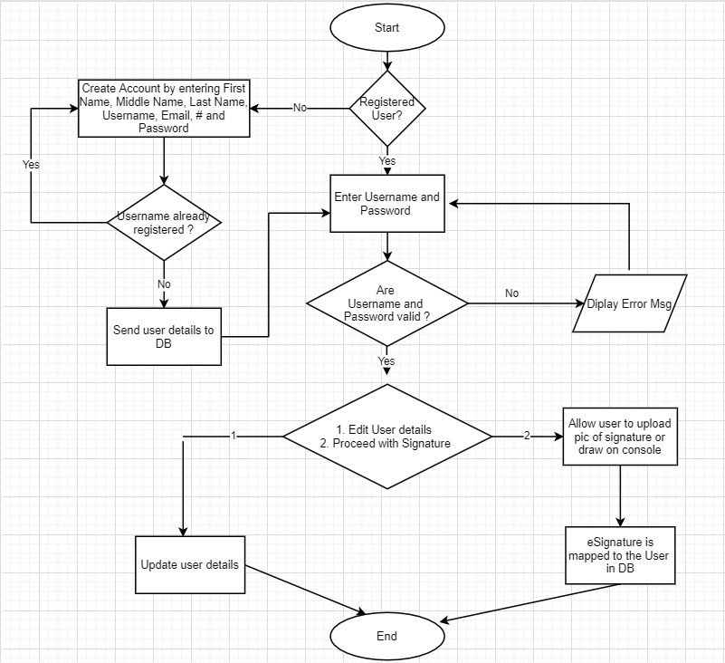

* 1. **Sequence Diagram**

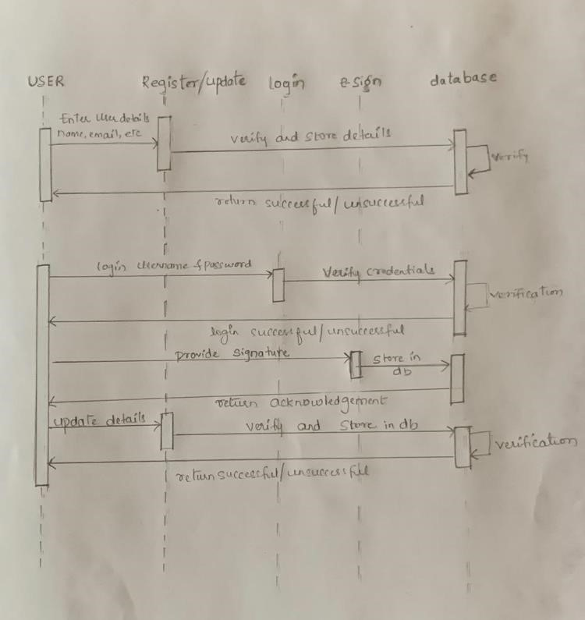

* **Design Constraint** 
  + 1. Signatures stored in the image format cannot be below 300 dots per inches (DPI)
    2. When users choose to draw their signatures, users can draw their signatures as many times as possible before submission.